Labor Unions:
Helping or Hurting America?

DOCUMENT A
... 1. Accidents and casualties are very numerous, partly owing to the exposed machinery and partly owing to carelessness .... It is really painful to go round among the operatives and find the hands and fingers mutilated, in consequence of accidents. 2. Unnatural or monotonous working positions ... in some cases [make the worker] round-shouldered, in other cases producing curvature of the spine and bow-legs. 3. Exhaustion from overwork. In consequence of the long hours of labor, the great speed the machinery is run at, the large number of looms the weavers tend, and the general over-tasking, so much exhaustion is produced, in most cases, that immediately after taking supper, the tired operatives drop to sleep in their chairs .... 4. Work by artificial light. It is very injurious to the eyes. The affections consist principally in conjunctivitis, opacity of cornea, granulations of the lids, &c. 5. The inhalation of foreign political bias, the country would soon be rid of law- breakers and disturbers of the peace. As this plan has now been adopted, it will be far-reaching in its effect, and stop mob gatherings, riotous speech making, and other such bad incentives which recently have been so conspicuous in Chicago, Milwaukee, St. Louis, and elsewhere ....
Source: The Impact of the Factory on Worker Health, Dr. John B. Whitaker, 1871.

DOCUMENT B
... Since the old system of working in little shops was abandoned for that of large manufactories, there has been a steady diminution in the length of the working season per year. Before the time of factories, there would be a steady run of employment for from seven to ten years, only interrupted by commercial depressions or revulsion. The working hours would be from twelve to fifteen. The season for lighting up was from September 20 to May 20. Since that time, there has never been a year of steady work. At first a month only would be lost; now it has got so that we lose over four months' time every year. The system is worse here than elsewhere because machinery has been thoroughly introduced.
Source: A Worker Stresses Seasonal Unemployment, 1871.

DOCUMENT C
The rapid displacement of men by women in the factory and workshop has to be met sooner or later, and the question is forcing itself upon the leaders and thinkers among the labor organizations of the land.
Is it a pleasing indication of progress to see the father, the brother and the son displaced as the bread winner by the mother, sister and daughter? ...
...The wholesale employment of women in the various handicrafts must gradually unsex them, as it most assuredly is demoralizing them, or stripping them of that modest demeanor that lends a charm to their kind, while it numerically strengthens the multitudinous army of loafers, paupers, tramps and policemen, for no man who desires honest employment, and can secure it, cares to throw his life away upon such a wretched occupation as the latter.
Source: An AFL Perspective on Women in the Work Force, 1897.

DOCUMENT D
IN a bend of the south bank of the Monongahela River, eight miles from Pittsburgh, nestles the thriving town of Homestead, a place of about 12,000 inhabitants, built up by the wealth and enterprise of the Carnegie Steel Company and the thrift of the artisans employed by that great manufacturing corporation.
Without the Carnegie mills there would be no Homestead. The interdependence of the works and the town is absolute.
The foundation of this immense concern, representing a capital of many millions of dollars, and employing nearly 4,000 men, was laid in 1880, when, according to the census report, Homestead had a population of less than 600. The firm which has made all this possible, which, by virtue of intelligent effort and phenomenal accumulation and utilization of capital has called into being a full-fledged American town, with schools, churches, prosperous, mercantile establishments, independent minor industries and a well-organized municipal government, is controlled by two men, whose names have, through the events to be recorded in this volume, been made familiar as household words the world over— Andrew Carnegie and Henry Clay Frick.
Source: Homestead: A Complete History of the Struggle of July, 1892, Arthur G. Burgoyne, 1893.

DOCUMENT E
I have said before that the Knights of Labor is a body capable of immense good. It could, in harmony with the trades unions, do anything under the sun. . . . I was for 12 years a true K. of L., but when they would force upon me what I would not permit my employer to do it was time for us to part. How many of you, if your employer said you should not belong to a labor union, would accept this dictum? . . . . The Knights have formed an organization for educational purposes, but the union is the body that fights the battles between capitalist and employee. (Vol. 2: Baltimore Sun, Apr. 7, 1887)
Source: Letter by Samuel Gompers to The Baltimore Sun, 1887.

DOCUMENT F
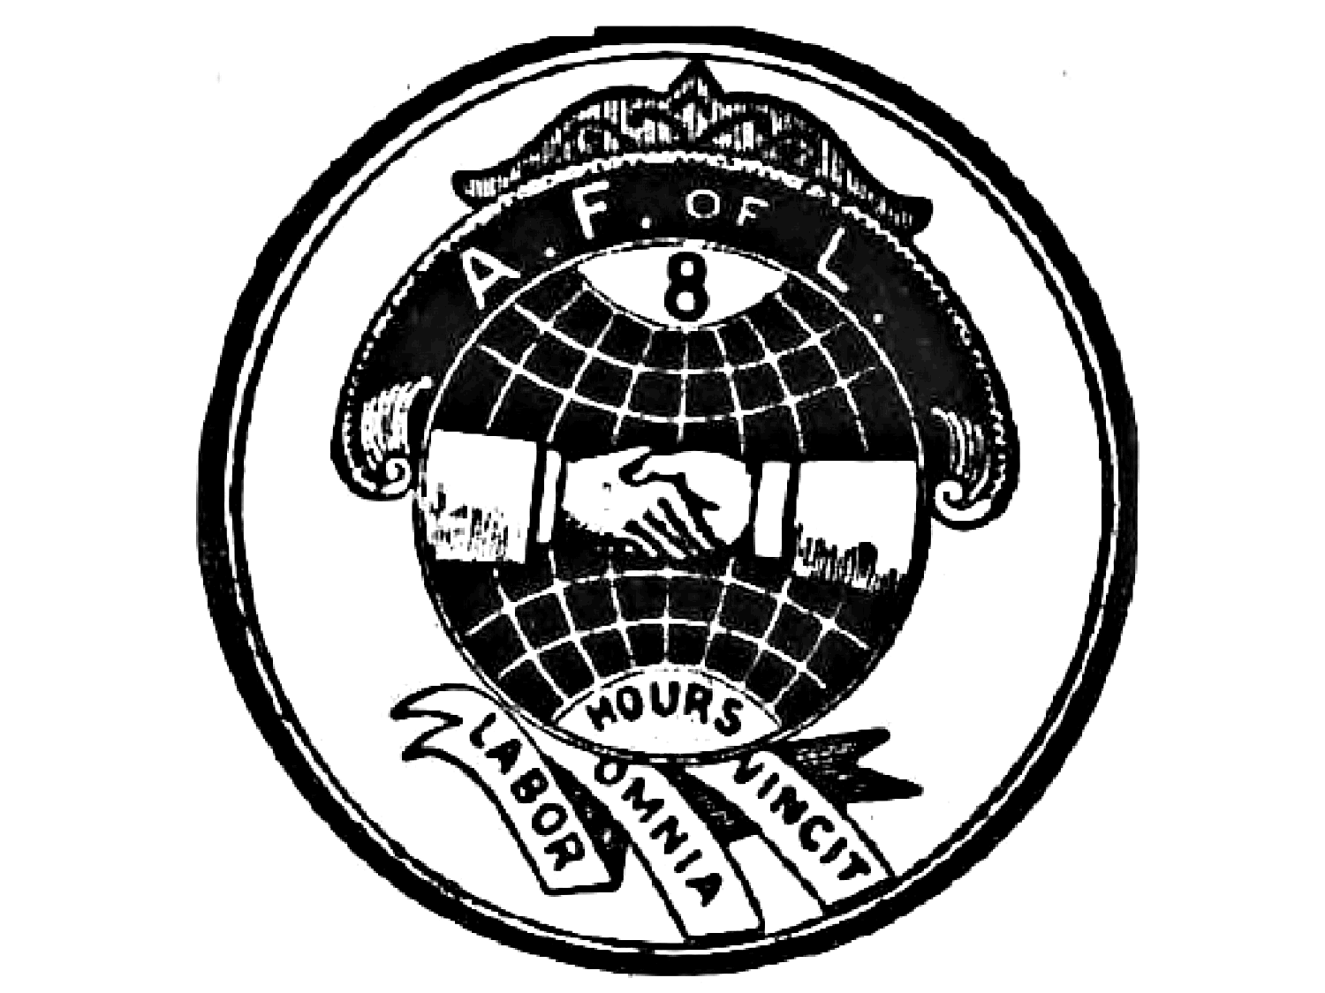
Source: American Federation of Labor seal, 1900.

DOCUMENT G
A true American sentiment recognizes the dignity of labor and the fact that honor lies in honest toil. Contented labor is an element of national prosperity. Ability to work constitutes the capital and the wage of labor the income of a vast number of our population, and this interest should be jealously protected. Our workingmen are not asking unreasonable indulgence.
The laboring classes constitute the main part of our population. They should be protected in their efforts peaceably to assert their rights when endangered by aggregated capital, and all statutes on this subject should recognize the care of the State for honest toil, and be framed with a view of improving the condition of the workingman.
Source: Letter to the Democratic Convention, Presidential nominee Grover Cleveland, August 18,1884.

DOCUMENT H
SECTION 1. Every contract, combination in the form of trust or otherwise, or conspiracy, in restraint of trade or commerce among the several States, or with foreign nations, is declared to be illegal. Every person who shall make any contract or engage in any combination or conspiracy hereby declared to be illegal shall be deemed guilty of a felony, and, on conviction thereof, shall be punished by fine not exceeding ten million dollars if a corporation, or, if any other person, three hundred and fifty thousand dollars, or by imprisonment not exceeding three years, or by both said punishments, in the discretion of the court.
Source: The Sherman Anti-Trust Act, 1890.

DOCUMENT I
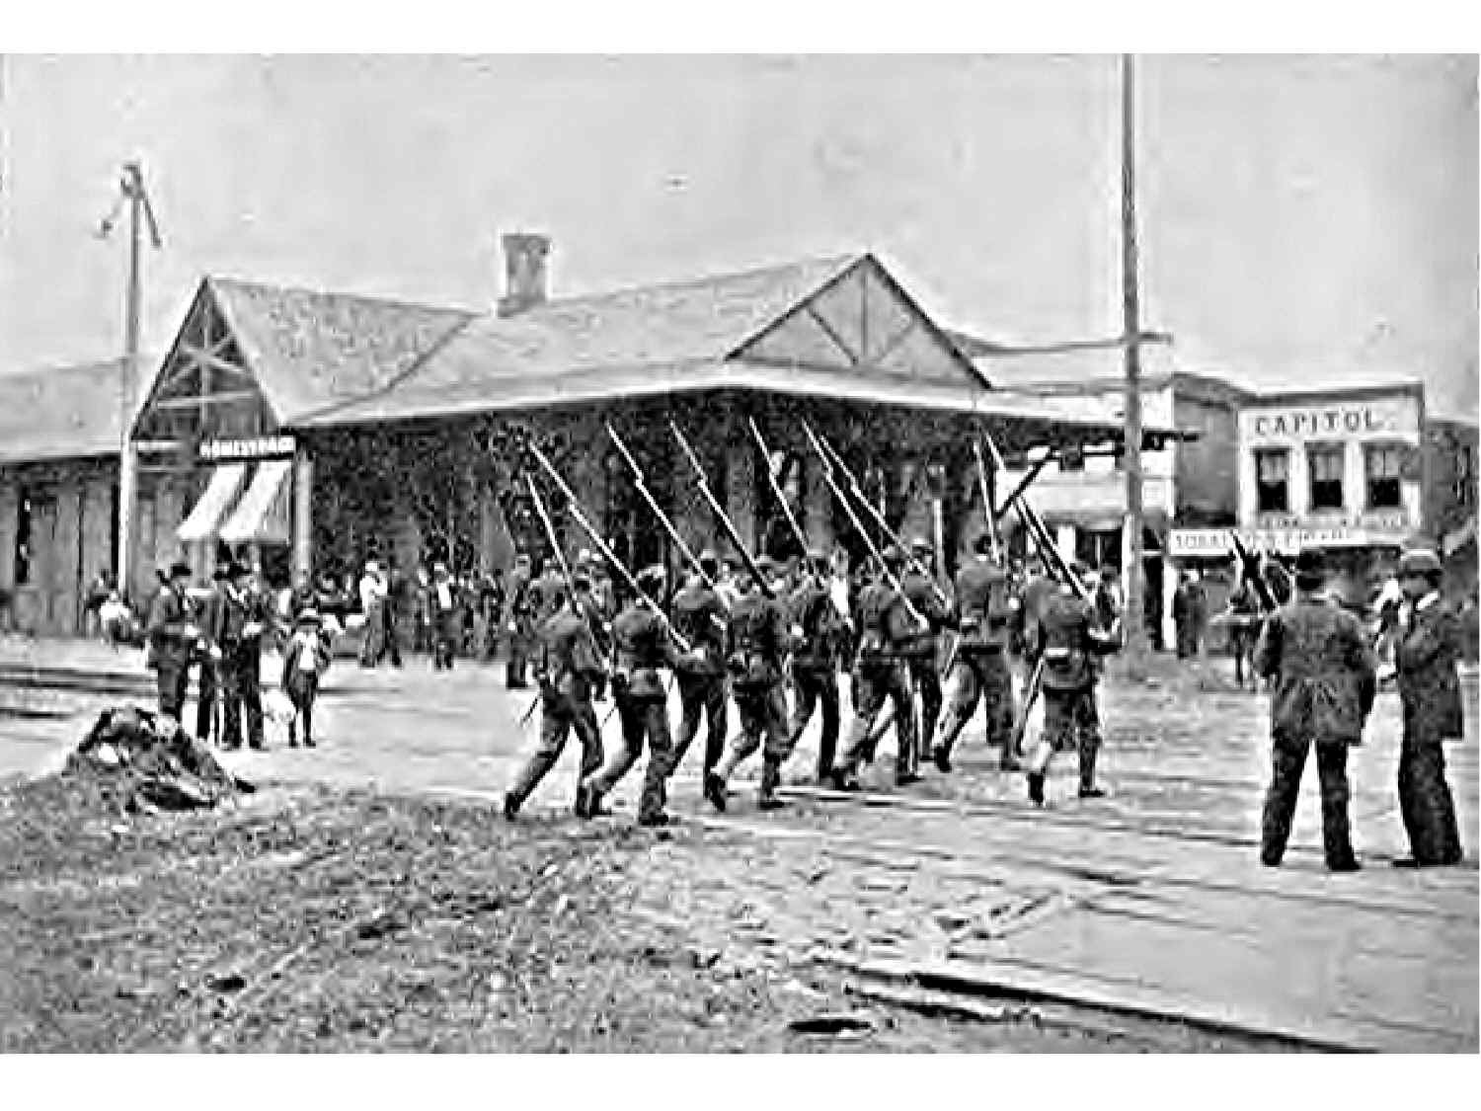
Source: Pennsylvania Gazette, 1892. Title: "Homestead: Patrol Guard, Company "D," 15th Penn.,
Passing the Railroad Station to Disperse Groups of Strikers.

The rise of Labor Unions from 1870 to 1900 transformed the relationship between industrialists and labor permanently. However, this period saw great conflict between these two groups, often erupting in violence. Using the documents above answer the following question in DBQ format:
The rise and implementation of Labor Unions was a necessary event for the growth of the United States economy, providing a much needed balance between workers and industrialists. Assess the validity of this statement.

